Software Requirements Specification

for

Cafeteria Ordering System, Release 1.0

Prepared by Group 3

April 2, 2023

Table of Contents

Table of Contents 2

Revision History 2

1. Introduction 2

1.1 Purpose 2

1.2 Document Conventions 3

1.3 Project Scope and Product Features 3

1.4 References 3

2. Overall Description 3

2.1 Product Perspective 3

2.2 User Classes and Characteristics 3

2.3 Operating Environment 3

2.4 Design and Implementation Constraints 4

2.5 Assumptions and Dependencies 4

3. System Features 4

4. Data Requirements 5

4.1 Data Dictionary 5

5. External Interface Requirements 6

5.1 User Interfaces 6

5.2 Software Interfaces 6

5.3 Hardware Interfaces 6

5.4 Communications Interfaces 7

6. Quality Attributes 7

6.1 Usability Requirements 7

6.2 Performance Requirements 7

6.3 Security Requirements 7

6.4 Safety Requirements 8

6.5 Availability Requirements 8

6.6 Robustness Requirements 8

Revision History

|  |  |  |  |
| --- | --- | --- | --- |
| **Name** | **Date** | **Reason For Changes** | **Version** |
| Phuong Uyen | 8/15/13 | initial draft | 1.0 draft 1 |
| Minh Hoang | 9/28/13 | Update information | 1.0 approved |

# Introduction

## Purpose

This SRS describes the functional and nonfunctional requirements for software of the Document Managment System (DMS). This document allows users to read information related to the system and understand the system. Also rely on this document to develop and upgrade the system software in the future.

## Document Conventions

No special typographical conventions are used in this SRS.

## Project Scope and Product Features

The DMS is a system that helps employees working in offices and documents related work. The system simplifies and reduces complexity in sorting, searching and other tasks..

## References

1. <https://en.wikipedia.org/wiki/Document_management_system>
2. <https://www.academia.edu/8831452/Software_Requirements_Specification_for_FSoft_Documents_Management_System_Version_1_0_approved_Prepared_by_Group_3>
3. <https://www.tdx.cat/bitstream/handle/10803/6160/04Nfm04de12.pdf;sequence=4>

# Overall Description

## Product Perspective

This project provides easy document handling functionality, making work faster and more convenient. Shorten processing time and easily store documents with high security to prevent document information from being exposed.

## User Classes and Characteristics

|  |  |
| --- | --- |
| Processing Unit | The Processing Unit is responsible for receiving all incoming documents from Agencies and Organization and handling such documents. Document handling includes taking numbers, recording incoming and outgoing dispatches and finally sorting. The classification includes the classification of incoming and outgoing documents. After the classification is complete, it will be sent to the Admin Department. |
| Admin Department | The Admin Department is responsible for reviewing all documents sent by the procesing Unit. Before reviewing, the documents must be carefully checked, if there are errors, they must be sent back to the Processing Unit for re-processing. |
| Documentation Unit | Documentation Unit is responsible for storing all types of documents after they have been reviewed. Simultaneously store data and security in the database management system. If it is found that the document has not been approved, it will be sent back to the Admin Department |

## Operating Environment

OE-1: The software was designed to run on any platform from Microsoft Windows 10 (64 bit or more).

OE-2: Databse: Microsoft SQL Server Management Studio 2018.

OE-3: Web XAMPP 5.6.15.

## Design and Implementation Constraints

CO-1: SQL commands for schemas queries.

CO-2: Connecting the database to XAMPP.

CO-3: Apply the Database.

## Assumptions and Dependencies

AS-1: The system will be deployed on a web platform and accessed from popular web browsers such as Chrome, Firefox and Safari.

AS-2: Users log into the system with their own username and password.

AS-3: All documents are properly classified and tagged for easy search and management.

DE-1: The system will use the database to store all documents.

DE-2: The system only supports storing documents in popular formats such as .doc, .pdf, .xls, and .ppt.

DE-3: The administrator account (admin) is the person who has control over all documents and has the right to add or remove other user accounts.

DE-4: The system will send a confirmation email when the document is uploaded and when there are any changes to the document.

# System Features

Users of the system can edit account information such as changing passwords, changing personal information or updating documents.

|  |  |
| --- | --- |
| Processing Unit functions: | Changing Personal Information  Review Documents  Classifying Documents |
| Admin Department functions: | Changing Personal Information  Managing Information of Employees  Approving Documents |
| Documentation Unit functions: | Saving Documents.  Saving Database of Documents. |

# Data Requirements

## Data Dictionary

|  |  |  |  |  |
| --- | --- | --- | --- | --- |
| Data Element | Description | Composition or Data Type | Length | Values |
| User name | a unique name or identifier that is used to identify a specific user on a computer system or online platform. It is typically used in combination with a password to provide secure access to the user's account. | Text | 30 |  |
| Password | a secret code that a user must enter to access a computer system, application, or file. It is used as a security measure to prevent unauthorized access and protect sensitive information. | Text | 30 |  |
| ProID | ID of Processing Unit | Text | 10 |  |
| ID Admin | ID of Admin Department | Text | 10 |  |
| DocID | ID of Documentation Unit | Text | 100 |  |
| ID | ID of Documents | Text | 50 |  |
| ID room | ID of different rooms | int | 15 |  |
| First name | typically refers to a person's given name, which comes before their surname or family name. | Text | 30 |  |
| Last name | refers to the family name or surname of a person, which typically comes after their first name. It is often used to distinguish between individuals with the same first name within a family or community. | Text | 30 |  |
| Middle name | Middle name is the name between a person's first name and last name. | Text | 30 |  |
| Address | the location where someone lives or receives mail. It typically includes information such as street number, street name, apartment or unit number (if applicable), city, state/province, and postal code. | Text | 80 |  |
| Phone number | a numerical sequence used to identify a specific telephone line for making and receiving calls. | int | 15 |  |
| Email | an electronic message or letter sent and received through the internet or other computer networks. It is typically used for communication purposes and may contain text, images, or attachments. | Text | 50 |  |
| Number | description unique number of documents | String |  |  |
| Title | Description content of documents | Text | 100 |  |
| Author | the person who write documetns | Text | 100 |  |
| Date | A date finishing documents | date, MM/DD/YYYY |  |  |
| Security | Status of document after storing | Text | 15 | 1: Safe  0: Unsafe |

# External Interface Requirements

## User Interfaces

The user interface for system will be compatible to any type of web browser such as Microsoft Edge, Google Chrome

**Login Form**

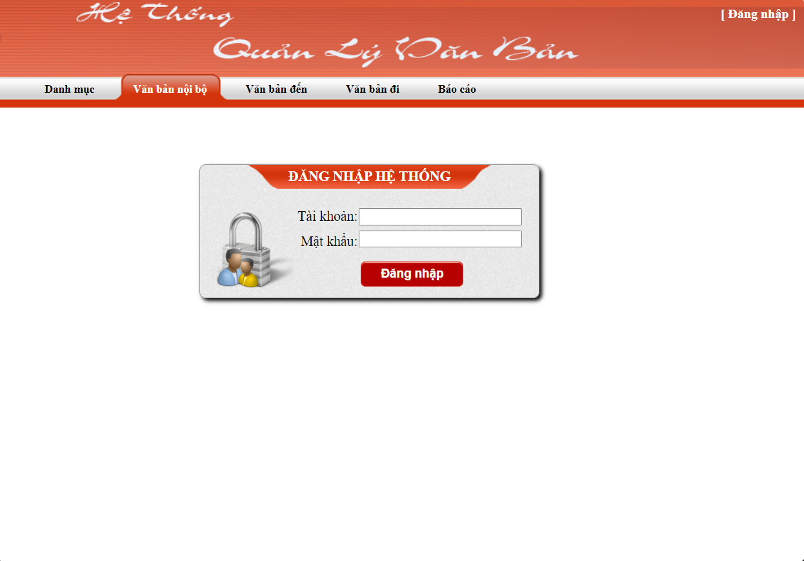

**Main Form**

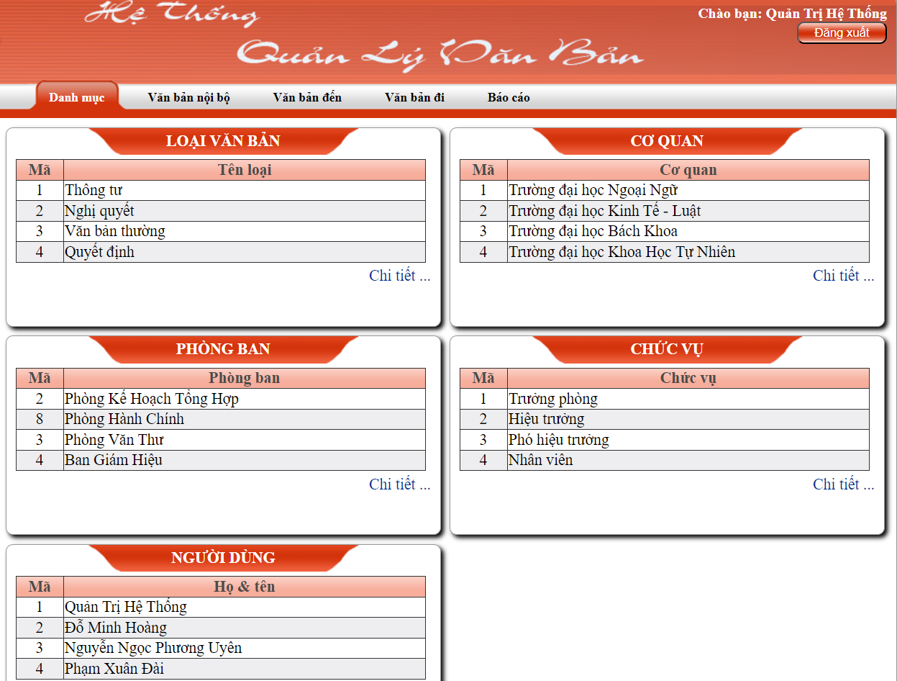

**Internal Document**

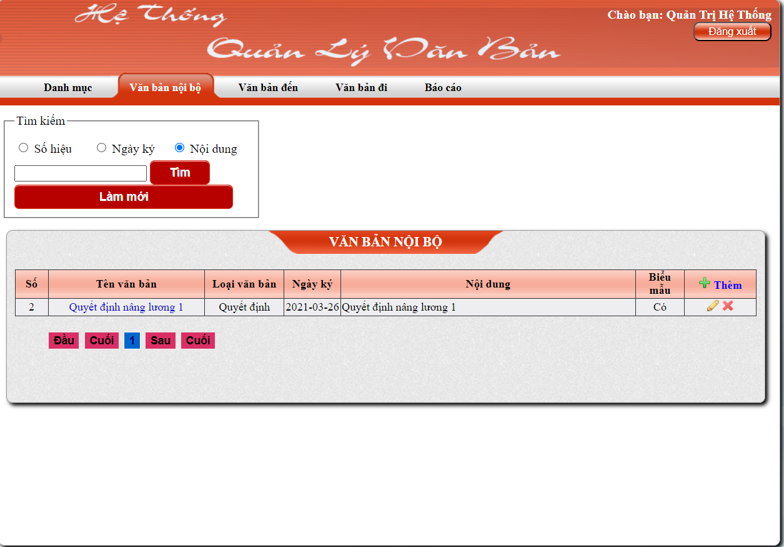

**Incoming Document**

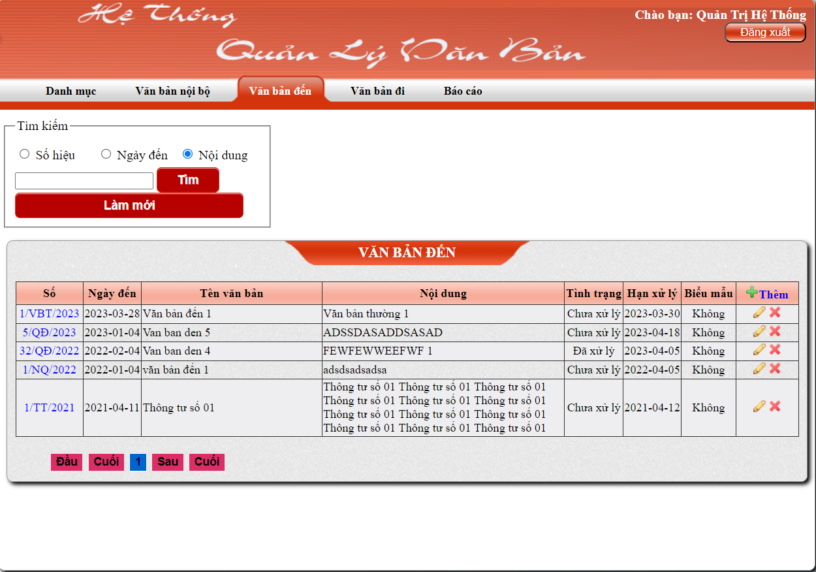

**Send Document**

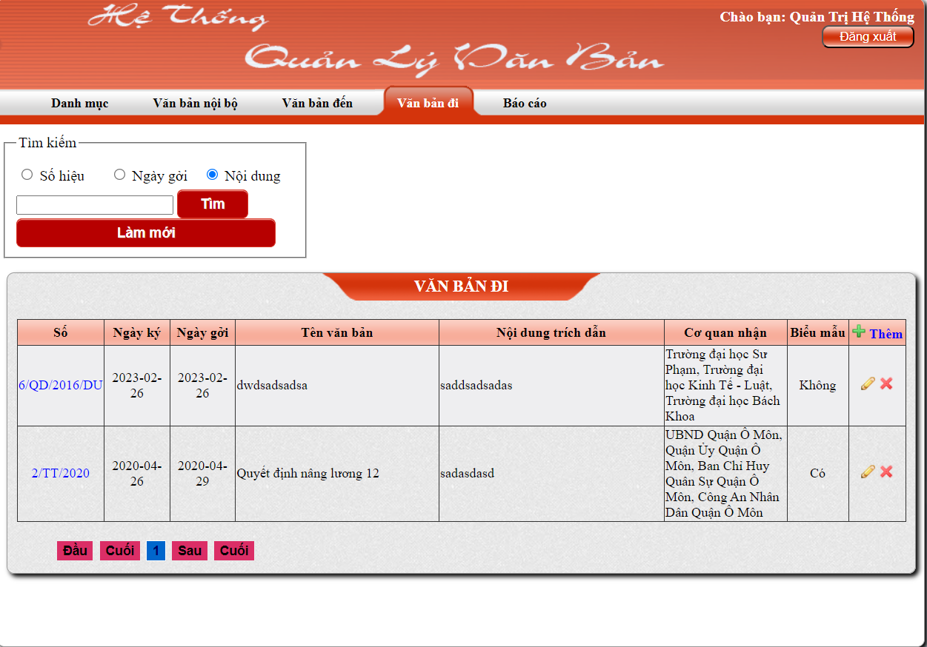

**Edit Internal Document**

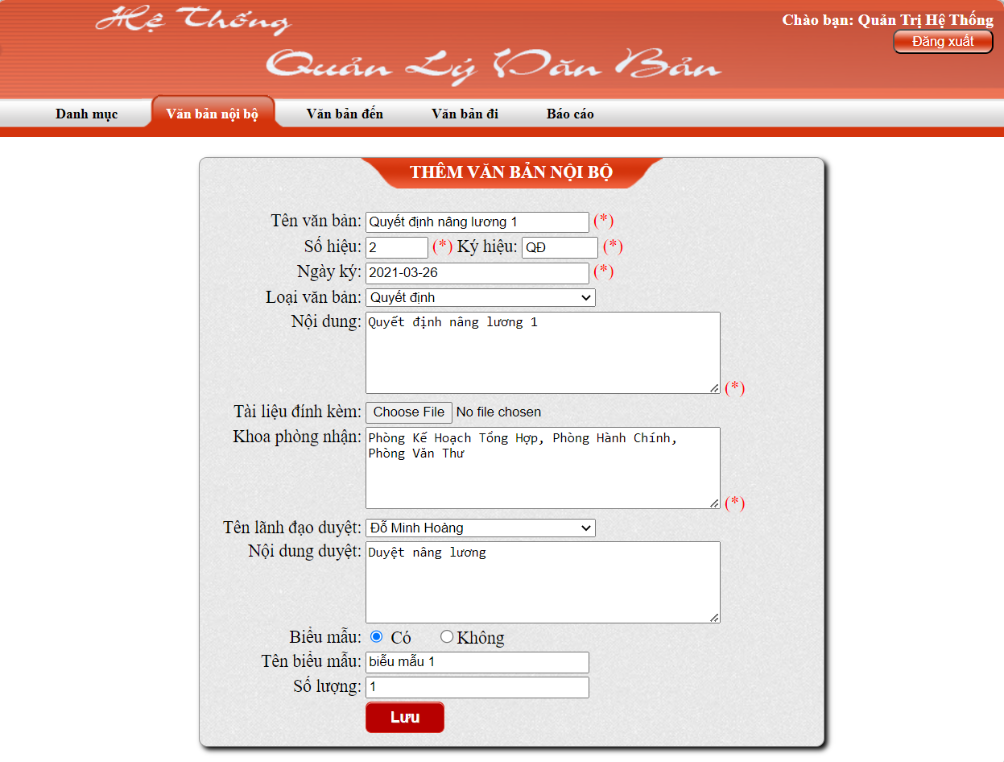

**Edit Incoming Document**

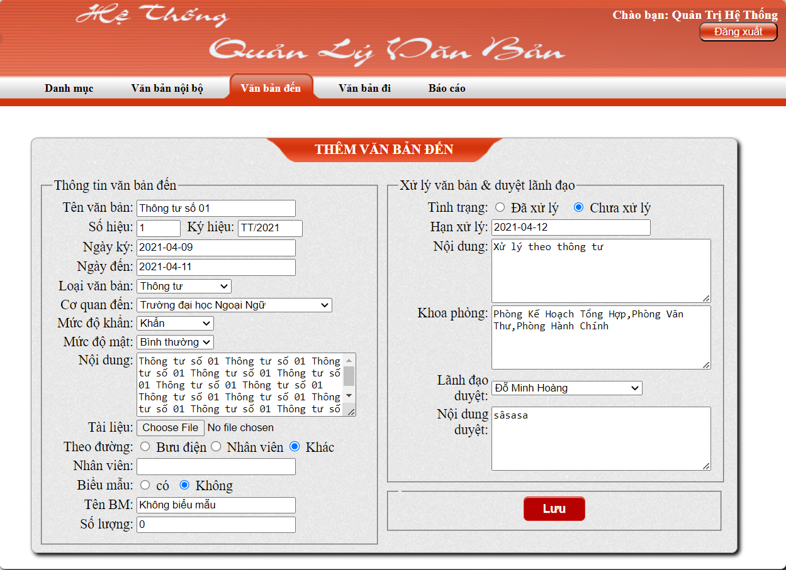

**Edit Send Document**

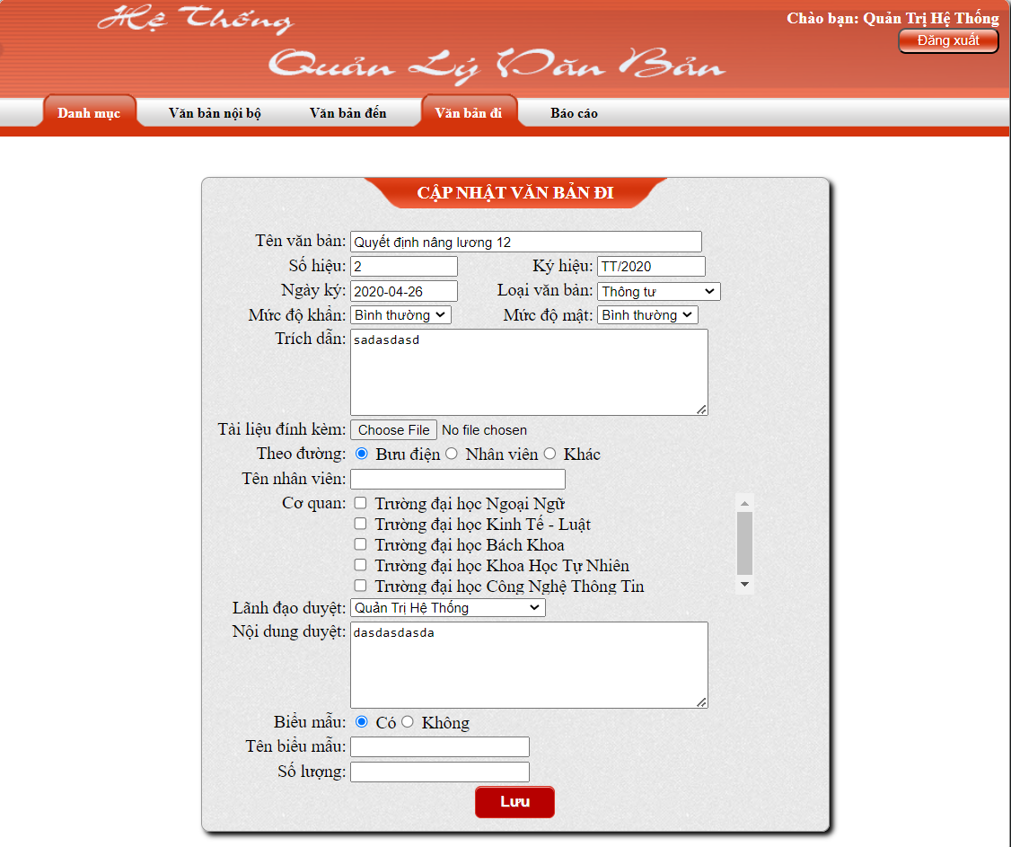

## Software Interfaces

SI-1: Web Server: OS Windows.

SI-2: Database Server: Microsoft SQL Server Management Studio 2018.

SI-3: Development End:

SI-3.1: PHP, CSS use for Front end.

SI-3.2: SQL Server use for Back end.

## Hardware Interfaces

HI-1: A specific computer must suitable in order to gain the maximum benefits from the system in an efficient manner.

HI-2: Documents will be received and sent to the branches of the National University. So need to keep a stable internet connection.

HI-3: A fax machine is required for documents to be sent.

## Communications Interfaces

CI-1: The system will send documents to designated departments and agencies.

CI-2: The system will display a notification about the review time.

# Quality Attributes

## Usability Requirements

USE-1: A new user must find the functions easily that he is looking for on the system.

USE-2: The layout and performance of functionalities of the system should be pleasing to the user.

USE-3: For the administrator, the updating of the system should be easy and secure.

## Performance Requirements

PER-1: Data in database should be updated as soon as user's update themselves.

PER-2: User's query must be displayed after 1 minute.

PER-3: Load time of UI will not take more than 3 seconds.

PER-4: Login proccess will be done within 1 seconds.

## Security Requirements

SEC-1: Access to the system will be protected by a user log in screen that requires a user name and password..

SEC-2: All data is protectively Marked.

SEC-3: Only authorized accounts can access certain documents.

## Safety Requirements

SAF-1: Maintaining backup give the guarantee to the system database security. In any case of problem system can be restored..

## Availability Requirements

AVL-1: The DMS should be designed in such a way that the system is available 24/7.

## Robustness Requirements

ROB-1: The DMS is capable of handling system functions accurately and maintain the database without facing to unexpected failures..